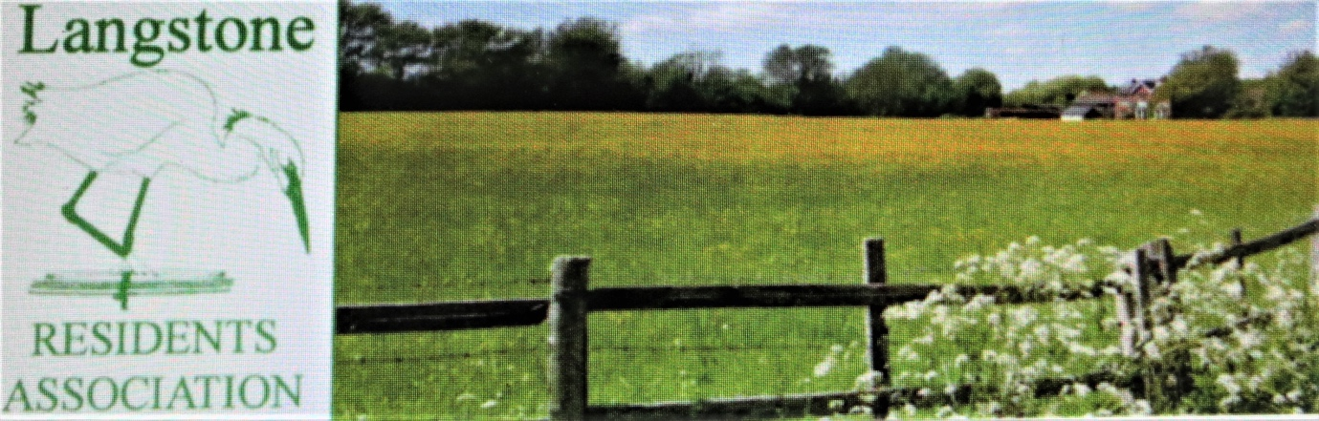
13 June 2022

Review Officer (Havant)
The Local Government Boundary Commission for England
PO Box 133
BLYTH
NE24 9FE

Our ref: DGP/JRP

Dear Commissioners

The Langstone Residents’ Association has examined your report proposing changes to the Electoral Boundaries in Havant, Hampshire. Our particular interest is in the St Faiths Ward, which includes our community of Langstone. The document fails to adequately explain the problem you consider needs resolving, especially a version of Appendix A showing existing data for the electorate in each ward which is missing.

Your proposals for Havant state there should be 36 councillors and 12 wards. An objective of the review is to ensure the number of electors represented by each councillor is approximately the same. At paragraph 24 you explain the figures upon which you based your analysis were provided by Havant Borough Council. They give forecasts for 2027 assuming a predicted 4% increase in the electorate from 2021 data. The notional target average of the number of electors per councillor is stated as being 2,696 in 2021 plus or minus 10%. The acceptable range is therefore 2,264 to 2,768. The target averages for 2027 is stated as 2,796 giving a range from 2,516 to 3,076. Is this average figure used across the whole Country?

An election was held in Havant on 5 May 2022 and based on the reported number of votes cast and allowing for spoilt papers the St Faiths Ward can be shown to have a current electorate of 8,231, so one third of that is 2,744. Adding the 4% factor for growth, St Faiths Ward will have 2,854 voters in 2027. Looking at the equivalent figures in that election for Hayling East and Hayling West the numbers for 2027 would be 2,623 and 2,360.

The above figures suggest the existing St Faiths Ward is predicted to be 58 voters above the mean, just over 2%, very clearly within the required range. Hayling West at a predicted level of 2,360 in 2027 is 436 below that mean i.e. 15.6%. So, it appears you seek to improve this ratio at the cost of St Faiths. Did you take account of the emerging Draft Local Plan (although currently suffering a setback) which seeks to increase the population of Hayling Island with potentially 800 or so new dwellings built over the next decade? The majority of that development is in the western/central area of the Island and will inevitably redress the statistical imbalance now quoted. 195 dwellings are already on site at Sinah Lane!

Referring to paragraph 36 on Page 7 of the report, we challenge your logic of there being “the best linkage between the Langstone area to the south of the A27 and Hayling Island”. The report further states at paragraph 60 that the proposal made is, “on the basis of shared community interest”. The examples given are Sweare Deep and the A3023! This a quite tenuous, almost ludicrous, link. The proposed Hayling Island West Ward is the least populated part of the Island, predominantly rural in character and with completely different social and economic concerns to Langstone. One needs to look at the map and note the geography of the two areas. Langstone is, and always has been, a part of Havant St Faiths. It is a closely knit suburb of the community related to the business of the town centre and the major light industrial areas of Broadmarsh and particularly, Langstone Park. The suggestion that we be politically isolated from those areas is unreal and fails to understand how this community interacts with its surroundings. The social and cultural focus for Langstone is Havant. The suggested boundaries would complicate enormously the elected member responsibility for a major area of South Havant and fails to understand the political context of this area and its relationship with the coastline of the mainland. Langstone relates to major environmental areas from Farlington to Emsworth,and is especially concerned about the requirement to integrate efforts on coastal protection and sea defences. The value and the need for elected member involvement is frequent to address issues here, which are rather different from those of Hayling Island. A simple numerical change that fails to recognise the dynamics of communities is flawed.

There is an obvious need to have this element of your proposal revisited with the direct input of those who live in Langstone. May we request an opportunity, together with the relevant elected members, to discuss this matter further.

Yours faithfully

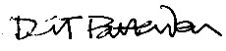

David Pattenden Dip Arch (Ports.), RIBA, BTP
Secretary - Langstone Residents Association

