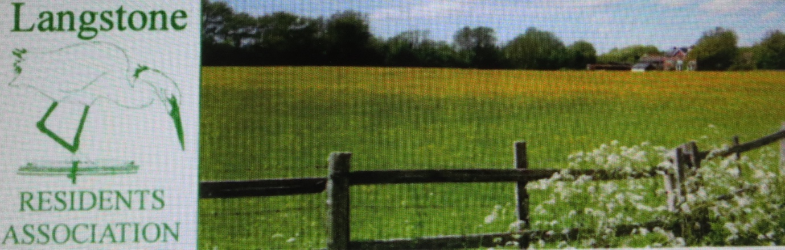

NEWSLETTER – January 2022
LANGSTONE PARK

Responding to a request from the LRA Secretary, David Pattenden to discuss the Virtual Consultation proposals with the Project Team for the Langstone Park Redevelopment, a virtual meeting was held on 5 January 2022. The Residents’ representatives were Angela Armstrong (AA), Andy Lewis (AL), and David Pattenden (DP). The Project Team were: - Tony Lawson (TL) from XLB site owners, Paul Newton (PN) – Barton Wilmore, Planning & Design Consultants, Mark Evans (ME) – PRC, Architects, John Russell (JR) – Motion, Transport Consultancy, Simon Rainsford (SR) – Envision, Sustainability Consultants. The meeting was organised by Miles Willshire and Samuel Carr - BECG Public Relations Consultants.

It was agreed, after introductions, to invite the LRA/LVA Officers to set out their concerns and then allow the various specialist Consultants to respond. A discussion could then focus on the information shared.

LANGSTONE PARK
Notes for virtual meeting on 5 January 2022

The objective behind the request for this meeting is simply to ensure the views of residents living next to or near Langstone Park are put before the Team and ideally adopted in the final proposals.

The original development of the site in the 60’s – 70’s was for a single user, IBM. Since then, the elegant buildings set in a park-like landscape have been subject to many changes, and an intensification of the use of the site. That slow incremental growth has modified the site to such a degree that it now impacts negatively on the neighbouring residential areas.

The concern of our members has been frequently voiced, and the Section 106 Condition which sought to limit the use of the access road on to Langstone Road, has been honoured. However, it is acknowledged that change is inevitable, and this has been recognised in the Draft Local Plan 2036, now at its Examination in Public stage.

The term Fourth Industrial Revolution (4IR) has been coined and this is seen as an encouragement for the Site Owners to redevelop the site and its buildings.

We are not entitled to discuss the Business Case for the proposals and accept the Local Planning Authority will have encouraged the Owners to optimise the site’s potential. Therefore, we must raise these matters which those of us living nearby fear may adversely affect our future enjoyment of the area. The Consultation documents have been studied and we wish to refer to the design and scale of the buildings and the connection of the site to existing infrastructure. Specifically

- Increased traffic generation particularly affecting the A3023
- Adequacy of on-site parking and its control
- Increased volumes of foul and storm water drainage and its potential to increase the flood risk from the sea as well as fluvial run off; SUDS principles
- Scale of the buildings – overlooking adjacent residential property
- Anti-social uses – noise; burning of waste; noxious smells
- Environmental threats – landscape damage; overnight illumination
- Carbon footprint – Energy used in demolition plus new build
- Planning gain – improvement of footpaths (51B) and access; cycleways

There are others worries about noise and dust during the construction phase and the length of time to see the scheme to completion.

These remarks are offered as an introduction to our concerns rather than a request to discuss the project per se.

Opening the responses, Mr Lawson (TL) advised the Site had been acquired by XLB a year ago and that it was committed to this location as a major Regeneration Project. The Owners have already invested in site amenities, the gymnasium, café, new signage, and landscaping works. The site, of some 40 acres (16 hectares) adds to the Company’s portfolio of similar facilities around the Country and they intend to develop it in line with a vision they have for such sites in the future.

They foresee a programme of change over a 10-year period starting with the approved works under Planning Approval APP/19/00703.

Paul Newton (PN) took over explaining the site is in decline quoting employment figures from 2018 of 2500 persons but falling to around 1200 at the present time. The accommodation does not meet the demands for modern business premises. The existing buildings are too inflexible and adaptation to present day requirements an uneconomic prospect. Extensive discussions have been held with Officers and Members of the Local Authority and, noting this to be one of the major employment centres in the Borough, the need for significant regeneration has been agreed. The site is included in the emerging Draft Local Plan 2036, at Section KP6 highlighting the opportunity to locate new R&D businesses in Langstone and leading the Fourth Industrial Revolution (4IR).

Mark Evans (ME) presented a series of drawings to illustrate the analysis undertaken of the site referring to the constraints imposed by the original buildings, mostly designed for manufacturing, and the two access points for vehicles.

He described a new pattern for circulation within the site for pedestrians and vehicles with a vision to distribute the buildings evenly across the site, thereby providing opportunities for more landscaping and people friendly spaces. The proposals are still at feasibility stage, to support the Outline Planning Application due in February, and he described the concept of the design of the buildings, and choice of materials, aiming to produce an upmarket visual environment in keeping with the ambitions for wider R&D use.

The scale and mass of the buildings will replicate those to be replaced but the intervening spaces will be landscaped and, by avoiding large areas of car parking, night-time lighting can be of domestic residential scale and use LED fittings. Diagrams were shown to demonstrate the buildings will not result in any overlooking of adjacent residential properties. The question of storm water drainage is to be managed following the principles of Sustainable Urban Drainage (SUD) and will include rainwater harvesting for use within the site.

Simon Rainsford of Envision next explained the sustainability aspects of the proposals beginning by noting how poorly the existing stock performs compared with current standards. An ambition for the development is to achieve a Net Zero standard. SR quoted the statistics as follows: - the existing carbon footprint of Langstone Park amounts to 4668ton/CO2 per annum, made up of 3988ton/CO2 per annum of electricity and 682ton/CO2 per annum of gas. The redeveloped site will aim to cease the use of gas and reduce electrical consumption to achieve a carbon footprint of 962.75tn/CO2 per annum, approximately just 20% of current levels. In terms of energy consumption, at present the use is 494.51 kwh/m2 and the target will be 75kwh/m2, just 15% of current levels. There will not be any centralised heat generation but localised units adopting heat pump recovery technology and solar panels will be employed for power generation to supplement the need.

The new buildings will be designed to BREEAM Excellent Standards (Building Research Establishment Environmental Assessment Method) and the construction phase will seek to achieve a circular economy by recycling and maximising the reuse of the waste associated with the redevelopment of Langstone Park.

John Russell (JR)– Motion, Transport Consultancy, described the traffic analysis carried out and confirmed the restrictions on the use of the access road from Langstone Road will be maintained. He referred to discussions with Havant Borough Council and the ambition to improve access to the site for pedestrians and cyclists. The scheme will include an upgrading of a section of Footpath 51B along the eastern boundary, and he posed the question about the surfacing material and whether to separate the pedestrian and cycle paths. He requested feedback. He further mentioned an idea being examined of having the bus operator arrange a route into the site.

An employment target of 1585 jobs is being set, considerably lower than earlier levels which approach 2500. The Site access points seem to work satisfactorily and do not need to be modified. Large commercial vehicles will continue to be routed via Brookside Road. The revised road layout within the site will simplify circulation and control mechanisms are planned to prevent unauthorised access. Also, to ensure movement is clearly directed to any chosen destination new signage will be provided. Physical barriers will continue to be used, perhaps relocated, and an ANPR system installed to enforce regulations and discourage misuse. The problem of the access onto Langstone Road is recognised and the Hampshire County Council require an automatic counting system to monitor its use in line with existing regulations. Parking will be evenly distributed around the site and provided to the Local Planning Authority standard, currently one space per 45m2 of floor space. Thus, based on the proposed 63,290m2 of building a figure of 1406 spaces are to be provided, significantly fewer than the 1769 spaces proposed under the previous Approval APP/19/00703.

As part of a Q & A period, AL stressed the problem of the A3023 Langstone Road and commuter parking in adjacent residential streets. AA emphasised the point referring to a history of inadequate on-site parking resulting in overspill across Langstone. She highlighted the effect of “call centre” use and asked if any major users had been identified given recent press speculation about an Amazon distribution centre? TL acknowledged the concerns giving an assurance these matters were understood and said efforts will be made to recognise such uses and avoid tenants having high vehicle usage. Further, he confirmed that other than existing tenants, XLB have yet to market the site to seek new occupants. He stressed that tenancy types are expected to be from high tech companies generating fewer employee numbers and vehicle movements than in earlier times.

DP referred to the award-winning buildings on the site asking if some element of this major heritage asset could be reused. He mentioned Building 6000 and its iconic landscaped central courtyard. ME and SR replied stating the building is outdated, inappropriate for modern users, and grossly inefficient in the use of energy. For these reasons it is unattractive to prospective clients and the costs involved in adapting it to better standards, as well as the technical difficulties, would be prohibitive.

The Meeting concluded with an acknowledgement, on both sides, of the value of having raised the various matters discussed. The Project Team are preparing an Outline Planning Application based on the work completed so far, but they undertook to continue to work with the local community as they seek to achieve a redevelopment which will enhance this part of Havant.

Secretary@lra.org
DP 09/01/2022

