Angela Armstrong – Chairman – 19 Hamilton Close, LANGSTONE, Havant, PO9 1RP

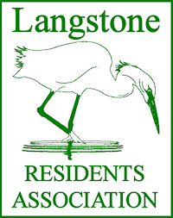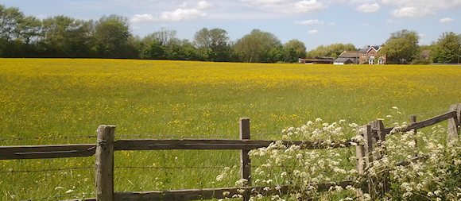

David Pattenden - Secretary – 18 Southbrook Road, LANGSTONE, Havant, PO9 1RN

30 July 2021

Adrian Ellis, Case Planning Officer

Planning Services

Havant Borough Council

Public Service Plaza

Civic Centre Road

**Havant**

PO9 2AX

By email planning.development@havant.gov.uk

Our ref: DGTP/SF/OBJECTION

Dear Mr Ellis

**APPLICATION No APP/21/00647 Outline application for 65 dwellings on land south of The Mallards and west of Langstone Road, Havant**

The Langstone Residents’ Association wishes to register an **OBJECTION** to the above scheme submitted by Persimmon Homes South Coast and validated on the 9 June 2021. The essential points of challenge are: -

1. **An economic objective.** This proposal will provide a short-term boost for sections of the building industry, but thereafter no economic benefit. It does not provide any long-term employment opportunities, it simply attracts a potential workforce from another part of the Borough which then adds to the transport load, on an already struggling system, as the new residents travel to their workplaces elsewhere. It does not assist in addressing the infrastructure problems of roads, drainage, or associated pollution.
2. **A social objective.** It may be argued the provision of 30% social, affordable, or intermediate rent houses address this criterion. However, given this is an Outline Application with the details “to be dealt with at Reserved Matters Stage” a serious question is raised about the realism of the proposal. This scheme would remove, or at best reduce a beautiful open space, with little guarantee about the final scheme.
3. **An environmental objective.** The proposal would remove a natural undisturbed space thereby denying a habitat used by several important endangered species. It raises the risk of flooding, by increasing the area of hard surfacing, and could generate greater potential for nitrate pollution.

The Association did not receive a formal Notification from you but has been informed of it by one of our members. An initial observation is to ask why the restrictive covenant, dated 20 March 1980 is not included in the ‘Constraints’ section? Another query concerns ownership of the land. The Application records Hampshire County Council as the owner whereas it is known part of the site is owned by a local Trust and the piece proposed for development is leased to a property management company. Such details should be clarified to establish who the beneficiaries will be if this application succeeds. It would be interesting to know what Pre-Planning Advice was given to the applicant.

The restrictive covenant protects the 3.7 hectares of land from any kind of residential development. Borough Officers have recognised this as being in place and previous Administrations have always honoured the Agreement.

The land, known locally as Southmere Field, provides a carbon sink which makes a modest contribution in dealing with the pollution generated on the A3023 that forms its eastern boundary. Additionally, as an undisturbed field now used only for a hay crop, it provides a major ecological refuge for several species of birds including curlew. The Sunday Times (25 July 2021) reported efforts to create an appropriate environment for curlews on the Sandringham Estate to encourage their recovery in England. This endangered species uses Southmere as a high tide roost and feeding ground during the winter. Barn owls are known to hunt over the field and very rare bat species are native to this area. These are important considerations.

As an unploughed open space, it is a vital link in the green corridor which flows between Chichester and Langstone Harbours benefitting the wildlife and providing an environmental haven in this part of Havant. It contributes greatly to making Langstone the attractive place it is

The A3023 Langstone Road is quite notorious for traffic queues and delays. As the only road link to Hayling Island, a tourist destination generating considerable income to the Borough, it is very heavily used and frequently at as standstill. The nose to tail vehicles pollute the atmosphere and disrupt many services. A Transport Assessment was undertaken as part of an Infrastructure Study for Hayling Island to support the emerging Local Plan 2036. That TA acknowledged the scale of the problems created by the single carriageway road and proposed several mitigation measures. These works may take decades to implement but will not improve the bottleneck caused by the section of road between the A27 trunk road and the road bridge. An additional 65 dwellings would seriously exacerbate the situation. Havant Borough Council has recognised this problem and included a Policy, NI, in its Draft Local Plan. Until the Plan is Adopted the Council resolved to refuse all planning applications seeking to create new access points on to the A3023 to limit further loading. This application assumes that control will not apply to this site because it indicates an unworkable access onto the existing road serving The Mallards. The spirit of Policy NI should be recognised and implemented.

At the present time the Langstone coastline is subject to a study to deal with improving flood defences. Coastal Partners are using data to show how rising sea levels, caused by global warming, will impact this area. Recent floods around the world emphasise the need for action. A factor influencing flooding is the increase in hard paving, the result of building works, which removes porous land and its ability to absorb water. A SUDs scheme for 65 dwellings cannot prevent more rainwater from affecting the storm water drains when existing porous surfaces are hard paved. The foul water systems will also be impacted by additional housing, leading to yet more incidents of unauthorised discharges of effluent into the harbour. The question of nitrate neutrality needs to be addressed. The Warblington Farm idea cannot be the answer to all the building proposed across the Borough.

Southmere Field is a symbol of Langstone and indicates to the thousands of annual visitors that pass by, their approach of their holiday destination. It is a well-maintained link to our agricultural past and provides a visual setting for the adjacent Mill Lane Conservation Area to the south. The Langstone Residents’ Association has in its Aims the duty to safeguard, maintain and improve the amenity of Langstone. To that end we must **object** to this Application and seek confirmation that our views are reported to the Development Management Committee.

We make no apology for this lengthy statement. It is made to ensure Members understand the context in which the fundamental objection, on planning grounds, is made. May we suggest the developer ‘build out’ those sites in Havant that have already been granted Planning Permission, and lie derelict, instead of destroying Southmere Field.

Yours sincerely



David Pattenden Dip Arch BTP RIBA

Secretary

Langstone Residents’ Association

c.c. Chairman and Members of the LRA Committee

Chairman - LVA

Councillors Jackie Branson, Tim Pike and Imogen Payter