Angela Armstrong – Chairman – 19 Hamilton Close, LANGSTONE, Havant, PO9 1RP

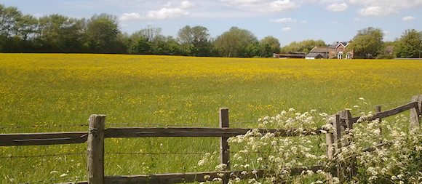

David Pattenden - Secretary – 18 Southbrook Road, LANGSTONE, Havant, PO9 1RN

19 August 2019

David Eaves

Principal Planning Officer

Planning Services

Havant Borough Council

Public Service Plaza

Civic Centre Road

**Havant**

PO9 2AX

Our ref: DGTP/LTP/OL/19/08/19

Dear Mr Eaves

**LANGSTONE TECHNOLOGY PARK – APP/19/00703**

The Langstone Residents’ Association wishes to register an OBJECTION to the above scheme. Our thoughts were expressed at the Development Consultation Forum held on 21 May 2019, when we hoped the Owners and their Agents might have listened to our concerns about the part demolition of Building 1000, reconsider that strategy and the resultant consequences of concentrating most of the on-site parking in the eastern sector of the site.

The objection now raised is focused on highways matters, the effect the proposal will have on the A3023 and the loss of local amenity resulting from the further overloading of Langstone Road.

Are we to assume this Application is to be processed under the terms of the existing Local Plan? The draft Havant Borough Local Plan 2036 is just months away from Adoption and a critical element of the new Plan is the Borough Transport Assessment, which remains unresolved, and importantly for Langstone, the question of the A3023 south of the Langstone Interchange with the A27. Widespread concern about this element of road infrastructure has yet to be addressed and the Applicant’s reference to the idea of signalising the access road junction at this point is both misleading and irrelevant.

The Langstone Technology Park features prominently in the draft Havant Borough Local Plan 2036 - Policies.

At Section KP6, para 3.110 there is reference to 4,000 employees and 1,500 car parking spaces and para 3.113 states “the site would benefit from improvements to its access infrastructure.” It continues at para 3.117 – bullet point 6, to highlight the “opportunities to increase permeability of the site by breaking up the large areas of car parking.” The next paragraph – 3.118 Delivery, states “*The Council is committed to the continued success of the Park and considers that further development is necessary to achieve this. Nonetheless, the site also faces challenges in terms of on-site and off-site infrastructure, which need to be fully considered and addressed. The Council will work collaboratively with owners and managers of the site, their tenants and local communities to facilitate needed further investment and development of the site.*”

The current planning application clearly disregards much of this, as yet un-adopted, guidance and should therefore be withdrawn and reconsidered.

The Framework Travel Plan is laudable, but typically pro forma and probably difficult to implement with so many diverse employers on the site. One suspects therefore it will not impact on the use of vehicles by the businesses or their employees.

Similarly, the Transport Assessment is a very lengthy and ‘standard’ treatise, quoting surveys, traffic volumes/movements and then giving results following several computer modelling exercises, which are only intelligible to traffic engineers. Local residents, as they sit in traffic queues, watching ‘U’ turns and waiting to move on to their appointments, will not be convinced of the value of the document.

The Agent’s representatives, speaking at the recent DCF, gave verbal assurances there would be greater use made of the western access – Brookside Road. This was said to be primarily for HGV’s. What is missing from this application is a description of the mechanisms to be introduced to enforce/oblige drivers to use the alternative access point.

No regard is given to the Policy KP6 – para 3.117. Instead of breaking up the “large areas of car parking” this scheme will concentrate much of the 1888 spaces to the east side of the site, closest to the access onto the A3023! Inevitably, any driver wishing to move to the north, east or south will use this access. Consequently, the quality of air available to local residents will be degraded by nitrous oxide pollution and thus adversely affecting our amenity.

The Langstone Residents’ Association therefore objects strongly to the present proposals for restructuring the Langstone Technology Park. Those objections will continue until the application is modified to demonstrate the positive measures to be put in place to enforce the control of the increased use to be made of the access road at its junction with Langstone Road. The increase in employee numbers and the significant expansion of the car parking provision indicates a scale of development beyond that expected by the local community. Regardless of the Applicant’s technical Transport Assessment, it is self evident that this proposal will have a major impact on the already severe traffic problems around the Langstone Interchange, both north to the Town Centre and south towards Hayling Island. This scheme must be withdrawn pending the completion of the critical Borough wide Transport Assessment, part of the Infrastructure Delivery Plan.

The LRA trusts you will make these points known to the Committee/Cabinet Members charged with the duty of determining this Application.

Yours sincerely

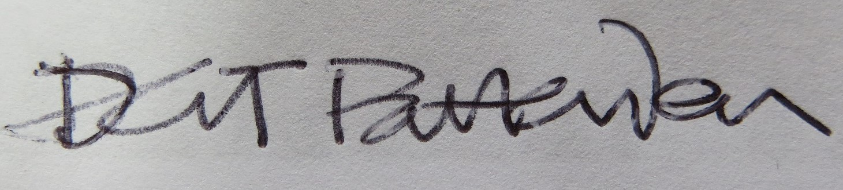

DGT Pattenden

David Pattenden Dip Arch BTP RIBA

Secretary

Langstone Residents’ Association

c.c. Chairman and members of the LRA Committee

Chairman - LVA

Councillor Jackie Branson

Councillor Tim Pike

Councillor David Guest