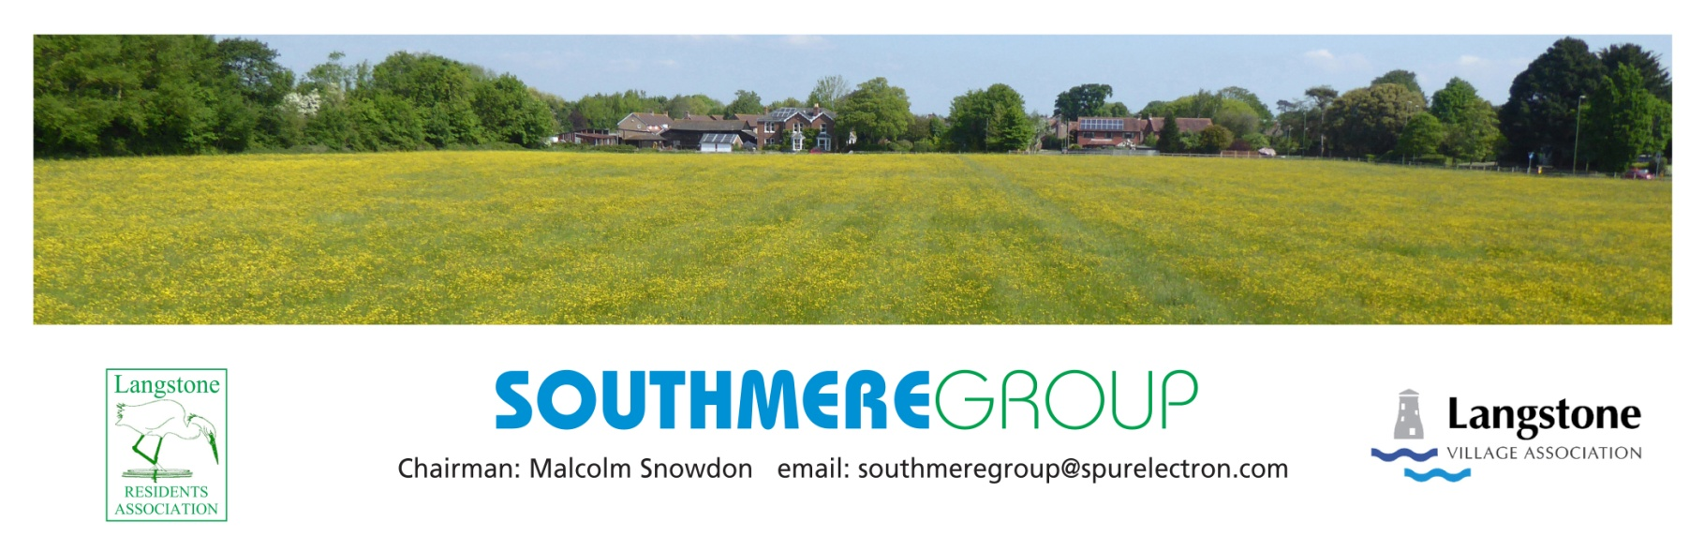
Information Notice #2 February 2019

GOOD NEWS!
Southmere Field is not included in the Local Plan Site Allocations

Havant Borough Council have published the list of sites needed to meet their Housing targets by 2036 and Southmere Field is not included. This is good news and is the only sensible conclusion given the relevance of the Covenant remains unchanged.
However, the field remains a highly attractive prize for development, with owners keen to liquidate their asset. Now is not the time to be complacent and an application for development can be made at any time and so the Southmere Group will continue its existence for as long as there is a need to defend the field.
The idea of separating the Covenant from other planning issues focussed our argument and the Group would like to thank all those residents who gave their support. We would also like to add our thanks to Council Members who supported the validity of the Covenant while other Councillors “sat on the fence!” leading us to wonder whose interests they were favouring.

Awl040519

