Angela Armstrong – Chairman – 19 Hamilton Close, LANGSTONE, Havant, PO9 1RP

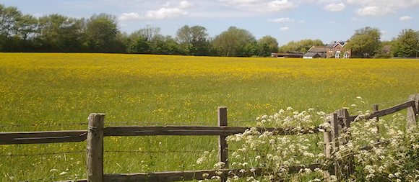

David Pattenden - Secretary – 18 Southbrook Road, LANGSTONE, Havant, PO9 1RN

16 January 2020

David Eaves

Principal Planning Officer

Planning Services

Havant Borough Council

Public Service Plaza

Civic Centre Road

**Havant**

PO9 2AX

Our ref: DGTP/LTP/OL/16/01/20

Dear Mr Eaves

**LANGSTONE TECHNOLOGY PARK – Proposed part demolition of Building 1000 and associated works; the erection of new flexible use industrial units; and a new parking layout with associated works to layout and access and felling of two trees subject to a Tree Preservation Order (Norway Maples)**

I refer to your letter dated 3 January 2020 advising of the receipt of revised plans and supporting information relating to the Planning Application Ref: APP/19/00703 for Langstone Technology Park.

Whilst the Langstone Residents’ Association and the Langstone Village Association maintains its concerns about this proposal, it is acknowledged the developer –Messrs Rapleys, in their letter dated 19 December 2019, intend introducing physical measures to limit vehicular access to the new industrial units and the northern car park during the peak AM period – between 7:30 and 9:00 to the western entrance. The developer’s figures indicate this affecting 543 vehicles leaving the balance of up to 1342 vehicles able to use the eastern entrance, via the A3023 – Langstone Road, as well as the western entrance from Brookside Road. These controls are cautiously welcomed.

However, the proposal will not solve the problem of traffic, choosing to use the eastern access, of having to cross the north bound lanes of Langstone Road causing queuing and consequent traffic congestion on the A3023 and beyond.

The Traffic Assessment, carried out as part of the Infrastructure Study to inform the work on the Local Plan 2036, highlights the problems of the A3023 and suggests a number of possible “mitigation” measures. Among the “ideas” is a proposal to ban right hand turns into Woodbury Avenue by traffic travelling north, which may delay south bound traffic. The scale of this problem is measured in a handful of vehicles a day and not all in the morning rush period! This junction is virtually opposite the LTP access road, where potentially 1342 vehicles might seek to cross the congested north bound lanes of the A3023!

The thinking, by traffic engineers, about this location, its problems and how to solve them seemed muddled to say the least. Further, if this arrangement has the support of Highways England in its desire to maintain traffic flow on the A27, it should engage constructively in the process of finding a solution to an existing, and long standing, unsatisfactory situation. The commercial ambitions on the western side of the A3023 should not be given priority over the thousands of residential council tax payers to the east and south.

When IBM first developed this site, in the late 1960’s – early 1970’s, the question of access was recognised as a potential problem and in 1977/78 HBC together with Hampshire County Council, as the Highway Authority, signed an Agreement with IBM about the road limiting the number of vehicle movements permitted to use the access to 250 per hour, during the peak time. This Agreement was to be enforceable against successors in title. The number of motor vehicles in the 1970’s was considerably less than today, but traffic on the A3023 was heavy and the use of this access road was anticipated to be a problem. 50 years later the volume of traffic has multiplied several times and the number of parking spaces to be provided on the LTP site – 1885 is many times greater than that envisaged by IBM.

The community of Langstone does not wish to frustrate the provision of a major employment opportunity in Havant, but it does want a better, safer means of access that will not create a toxic environment or disadvantage all those who live here. Until a solution is found to this problem our objection to the proposal must stand.

Yours sincerely



DGT Pattenden

David Pattenden Dip Arch BTP RIBA

Secretary - Langstone Residents’ Association

c.c Chairman and members of the LRA Committee