IMPORTANT NOTICE

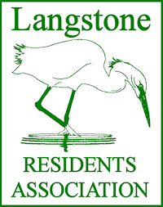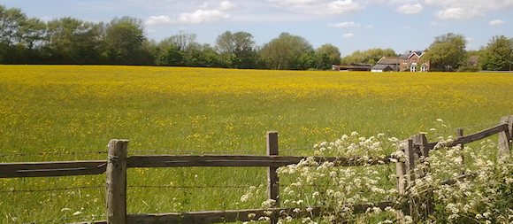

JANUARY 2019

Havant Borough Council will be approving the next stage of the Draft Local Plan 2036 at its Council Meeting on 30 January 2019. This will allow the Plan to progress to its “Pre Submission Consultation”, in other words, published for further comment. Of relevance to Langstone is the inevitable increase in traffic on the A3023 Langstone Road resulting from the 1000 additional homes proposed on Hayling Island. The Council Meeting will be open to the public.

You will know the Draft Local Plan has been through several stages during which it has been “informed” by an Evidence Base. Part of that evidence has been collected via an Infrastructure Study carried out across the Borough. A separate study was established for Hayling Island and it was informed by an Infrastructure Advisory Group (IAG). That group comprised representatives from the interested Residents’ Association of the affected areas, as well as Officers and Members of Havant Borough Council.

The Infrastructure Advisory Group was set up in 2017 and its first meeting was on 30 January that year! The input from the IAG was virtually complete by mid 2018 EXCEPT for the “all important” Transport Assessment. The majority of delegates contributing to the Study considered traffic matters to be the major issue especially the main road, the A3023.

Highway matters are a Hampshire County Council responsibility and HCC Engineers did give a series of presentations to the IAG. However, their reports were always qualified by a statement noting the data at their disposal was historic and needed to be updated. Surveys were undertaken and specialist consulting engineers appointed to analyse and interpret the new information. Many delays to that exercise were experienced during the past 2 years.

The Transport Assessment was eventually completed and passed to the Borough Council’s Officers in late December 2018. The elected Members received a presentation on 14 January 2019.

A meeting of the Infrastructure Advisory Group was called for 16January 2019, which included Agenda Items to explain National Policy, plus context and the role of a Transport Assessment in developing a Local Plan, the micro simulation model used and its output from the data collected, together with the implications this has on the Havant Local Plan, but NOT the data upon which the Consultants had worked. The omission of the information, despite requests for it to be made available at least 2 weeks before any formal meeting, caused concern resulting in a multitude of requests to postpone the meeting to allow the Lay Members of the IAG to see and evaluate this important material. The meeting was called, but to avoid appearing, accidently to concur with any recommendations, the representatives of the Residents’ Associations left the meeting having first repeated the request to have sight of the information before being expected to ‘sign it off’.

The necessity of having a new Local Plan is understood and accepted. The Borough’s Planners stress it is an essential tool to enable them to resist inappropriate development across the Borough. However, your representatives felt unable to accept and agree with information they had not been able to review and consider properly. Further, they failed to comprehend how a 2 week delay in the process could be so damaging. The Council Meeting will go ahead and the Plan inevitably approved. We, the IAG, have been denied the opportunity to complete the contribution which has been developing over the last 2 years.

This is a vitally important matter for Langstone. Another 1000 houses on Hayling Island, and the resultant traffic they would generate, together with the ongoing threat to Southmere Field, are issues that will impact significantly on our quality of life forever. Government Policy is no excuse for the failure to adequately listen to and respect the views of the people living in this area.

Please follow the news in the local press as it develops and express your personal opinion to your Local Councillors about the deteriorating environmental conditions we suffer as the result of extremely poor traffic management across the southern part of Havant.

Those members who responded to the last LRA/LVA Southmere Group Information Notice are acknowledged and thanked. Your continuing support is requested and very much appreciated.

DGP 18/01/19